By: Mohamed Sameh
2023/05569

1D Barcode Detection
Image Processing Project
Table of Contents
Executive Summary 4
Introduction 4
Background & Objectives 6
System Overview 6
Pipeline Architecture 6
Pipeline Diagram: 7
Step-by-Step Process 7
Step 0: Import 7
Step 2: Preprocessing & Gradient 9
Step 3: Thresholding & Morphology 10
Step 4: Contour Detection & Initial Candidate 13
Step 5: Contour Validation Functions 14
Step 6: Contour Detection & Initial Candidate 15
Challenges 17
Future Work: Barcode Decoding 17
Algorithms & Rationale 18
Usage Guide 18
Conclusion 18

Executive Summary
This project presents an automated barcode detection system using classical image processing techniques. The system is designed to accurately detect and isolate barcodes in images, regardless of their orientation, size, or proximity to other barcodes.
The detection pipeline combines grayscale conversion, gradient-based edge detection, thresholding, and morphological operations to highlight barcode regions, followed by contour extraction and validation to identify potential barcode candidates. For complex cases such as merged or stacked barcodes, specialized splitting strategies are applied to separate individual barcodes. Finally, Non-Maximum Suppression (NMS) is employed to remove overlapping or redundant detections, ensuring that each barcode is identified only once.
The resulting system is robust to noise, partial overlaps, and varying barcode orientations, providing reliable detection suitable for applications in retail, logistics, and inventory management. The project also emphasizes explainable and tunable classical computer vision techniques rather than machine learning, ensuring transparency and ease of adaptation

Introduction
Barcodes are widely used in modern commerce, logistics, and inventory management as a compact and efficient means to encode information about products. Rapid and accurate detection of barcodes in images is crucial for applications ranging from automated checkout systems to warehouse management and supply chain tracking.
Despite their ubiquity, barcode detection in real-world images presents several challenges:
- Variability in Orientation – Barcodes can appear at any rotation or tilt in an image.
- Noise and Background Clutter – Real-world environments often introduce visual noise, varying lighting conditions, and complex backgrounds.
- Overlapping or Merged Barcodes – Multiple barcodes may appear side by side or stacked, making individual detection difficult.
- Size Variations – Barcodes may range from small product labels to large shipping labels.
The primary objective of this project is to develop a robust, orientation-independent barcode detection system using classical image processing techniques. By leveraging gradient-based edge detection, thresholding, morphological operations, contour analysis, and intelligent splitting strategies, the system can:
- Detect barcodes of varying orientations and sizes.
- Handle merged or stacked barcodes by separating them into individual regions.
- Filter out noise and avoid false positives.
- Provide visual verification through bounding boxes for each detected barcode.
This project focuses on explainable computer vision methods rather than machine learning approaches, which ensures transparency, reproducibility, and easy adaptation for different image datasets or application scenarios.

Background & Objectives
Detecting multiple barcodes in a single image is essential for inventory management, retail automation, and logistics. The objective of this project is to build a robust pipeline that can handle varied orientations, lighting conditions, and noise levels in real-world images.

System Overview
Input: Images containing multiple barcodes.
Supported Types: EAN-13, UPC, Code 128, etc.
Dependencies: OpenCV, NumPy, Google Colab patches.

Pipeline Architecture
The pipeline consists of the following stages: Input Image → Grayscale + Blur → Gradient Computation → Thresholding → Morphology → Contour Extraction → Contour Validation → Large Contour Splitting → Non-Maximum Suppression → Visualization

Pipeline Diagram:
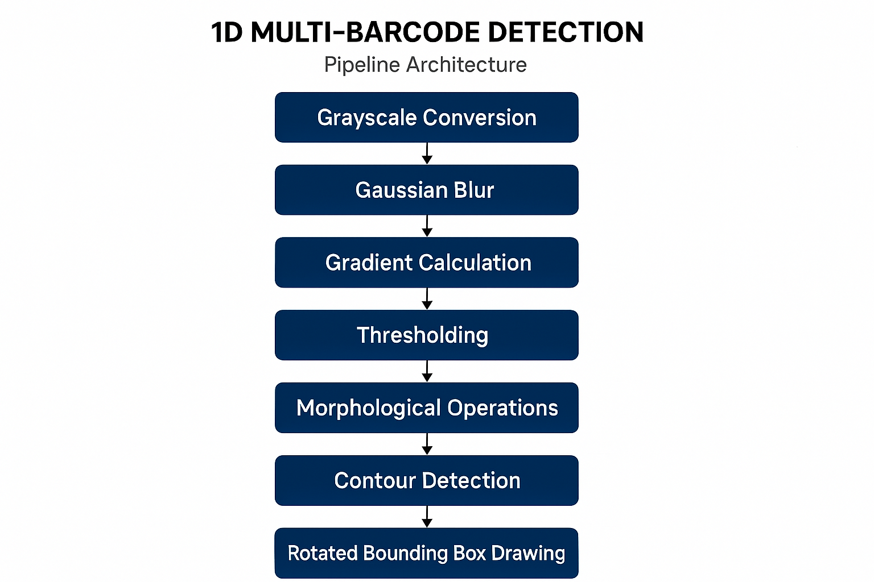

Step-by-Step Process

Step 0: Import
OpenCV (cv2): Core library for all image processing operations, including filtering, edge detection, morphological operations, and contour extraction. OpenCV provides highly optimized routines for real-time computer vision tasks.
NumPy (np): Provides array manipulation utilities and numerical functions, which are used for operations such as center distance calculations, array shifts, and gradient combination.
Matplotlib (plt): Used for visualizing images at each stage of the pipeline, which is essential for debugging and verifying preprocessing, thresholding, and detection results.
Google Colab Files (files): Used to upload images into the Colab environment for testing and demonstration purposes.
Best Practices:
Ensure that all libraries are installed (opencv-python, numpy, matplotlib) before running the pipeline.
For large-scale processing, the visualization (Matplotlib) steps can be disabled to improve speed.
Step 1: Image Loading & Preview
- Image Uploading: Using files.upload(), the user selects one or more images from their local machine. The system automatically retrieves the file path of the first uploaded image.
- Reading the Image: cv.imread() reads the image in BGR color space, which is standard for OpenCV.
- Visualization: OpenCV uses BGR, while Matplotlib uses RGB. Therefore, cv.cvtColor(image, cv.COLOR_BGR2RGB) is used to convert the color space for correct visualization.
- Purpose: This step allows the user to confirm that the image is loaded correctly and provides a baseline reference for the original input before any processing.

Key Notes:
- Always check the image shape and type after loading (image.shape) to avoid runtime errors in later steps.
- For larger images, consider resizing for faster processing during development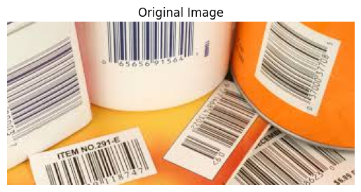
Figure 1: Original image with multiple barcodes.

Step 2: Preprocessing & Gradient
- Grayscale Conversion (cv.cvtColor): Barcodes are intensity-based patterns; color information is irrelevant for edge detection. Converting to grayscale reduces computation.
- Gaussian Blur: cv.GaussianBlur removes high-frequency noise that could create false edges. A (5,5) kernel is a compromise between smoothing noise and preserving barcode edges.
- Sobel Gradients:
- grad_x detects horizontal edges, grad_y detects vertical edges.
- Using both directions ensures orientation independence, crucial for barcodes that may be rotated.
- Absolute Conversion: cv.convertScaleAbs ensures gradient values are positive and in the 0–255 range for visualization.
- Weighted Combination: cv.addWeighted merges horizontal and vertical gradients equally, highlighting strong edges in all orientations.
- Purpose: This step produces a gradient map, emphasizing the barcode stripes while suppressing background noise
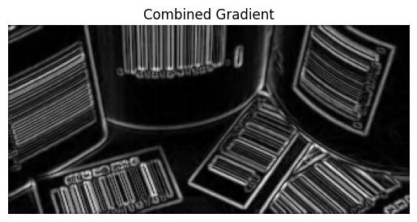
Figure 2: Combined gradient image emphasizing barcode edges.

Step 3: Thresholding & Morphology
- Binary Thresholding (cv.threshold)
- Converts the gradient image into a binary mask (0 or 255).
- cv.THRESH_OTSU automatically finds the optimal threshold separating barcode edges from the background.
- Output: binary – a clean separation of strong edges from weak/noise areas.
- Purpose: Provides a clear mask for contour detection.
- Morphological Closing (cv.MORPH_CLOSE)
- Uses a small (3,3) rectangular kernel.
- Closing = Dilation followed by Erosion.
- Purpose: Fills tiny gaps within barcode stripes without merging separate barcodes.
- Key point: very light closing is intentional to prevent merging nearby barcodes.
- Morphological Opening (cv.MORPH_OPEN)
- Uses a (2,2) kernel.
- Opening = Erosion followed by Dilation.
- Purpose: Removes small noise blobs that survived thresholding, such as isolated speckles.
- Visualization
- binary shows the raw thresholding result.
- clean shows the refined mask after light morphological operations.
- This helps verify that edges are preserved while noise is removed.
Best Practices & Notes:
- Kernel sizes should be adjusted depending on image resolution and barcode size. Too large kernels can merge separate barcodes; too small kernels may leave noise.
- Iteration counts in morphology affect aggressiveness; here, 1 iteration is sufficient for light cleaning.
- Always visualize the mask before contour extraction to ensure preprocessing works as expected.
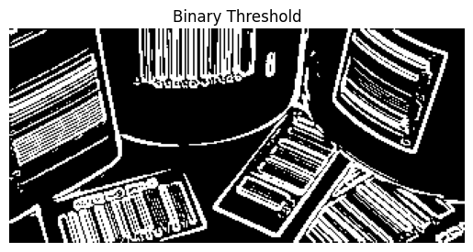
Figure 3: Binary image after thresholding.
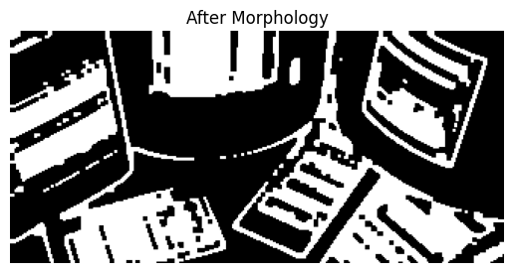
Figure 4: Cleaned image after light morphology.

Step 4: Contour Detection & Initial Candidate
- Contour Extraction (cv.findContours)
- Finds continuous boundaries of white regions in the binary mask.
- cv.RETR_EXTERNAL: Only retrieves external contours to avoid nested duplicates.
- cv.CHAIN_APPROX_SIMPLE: Compresses contour points for efficiency.
- Preparation for Candidate Validation
- output: Copy of the original image for visualization.
- img_h & img_w: Image dimensions for filtering and validation.
- LARGE_AREA_THRESHOLD: Threshold to flag potential merged barcodes (adjustable).
- barcode_candidates: List to store valid barcode candidates after processing.
Purpose:
This step identifies all potential barcode regions and sets up structures to filter and refine them in the next steps.

Step 5: Contour Validation Functions
- validate_contour
- Filters out contours that are too small, too large, almost square, or have an abnormal aspect ratio.
- Returns detailed info: rotated bounding box, area, center, and the original contour.
- Ensures only realistic barcode shapes are considered.
- calculate_iou & calculate_distance
- Utilities for Non-Maximum Suppression:
    - IoU detects overlapping bounding boxes.
    - Distance ensures detections are not too close to each other.
- non_max_suppression
- Removes overlapping or redundant detections, keeping the largest or most distinct candidates.
- Combines IoU and center distance to handle cases where barcodes are very close.
- split_large_contour
- Handles merged or large barcode regions using multiple strategies:
    - Horizontal erosion to separate side-by-side barcodes
    - Horizontal projection-based splitting
    - Vertical projection for stacked barcodes
    - Alternative horizontal erosion with different kernel sizes
    - Distance transform + watershed segmentation
  - Returns a refined list of candidate barcodes.
Purpose:
These functions form the core of the barcode validation and splitting logic, ensuring accurate detection even in challenging cases.

Step 6: Contour Detection & Initial Candidate
- Iterating Through Contours
    - Each contour is assessed for size and aspect ratio.
    - Large or unusually shaped contours are flagged as potential merged barcodes.
- Merged Barcode Handling
- If a contour is likely to contain multiple barcodes:
    - Extract the Region of Interest (ROI) from the mask.
    - Apply split_large_contour() to attempt separation using the multiple strategies discussed previously.
    - If no split is successful, treat it as a single barcode.
- Regular Contour Processing
- Contours that do not meet merging criteria are validated with validate_contour() to ensure they are plausible barcode shapes.
- Non-Maximum Suppression (NMS)
- After collecting all candidates, non_max_suppression() removes redundant or overlapping detections:
    - IoU threshold: 0.15 (aggressive suppression).
    - Distance threshold: 50 pixels (avoids nearby duplicates).
  - This ensures each barcode is detected exactly once.
- Visualization
  - cv.drawContours() overlays the final bounding boxes in green on the original image.
  - The plt.imshow() function displays the results for verification.
  - barcode_count shows the total number of barcodes detected after all filtering.

Key Points
- Aspect ratio checks help identify merged or unusual contours.
- Split strategies (erosion, projections, watershed) make the system robust against side-by-side or stacked barcodes.
- Aggressive but controlled NMS ensures no barcode is counted twice while preserving detection accuracy.
- This approach balances recall (detecting all barcodes) with precision (avoiding false positives).

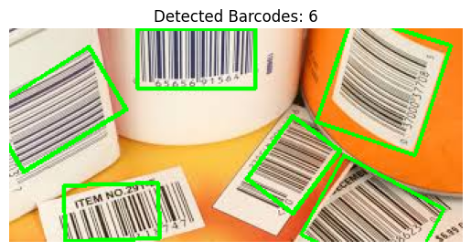
Figure 5: Detected barcode candidates with rotated bounding boxes.

Challenges
During the development of the barcode detection system, several challenges were encountered. Each challenge was addressed through careful design of the image processing pipeline and parameter tuning. The key challenges are as follows:
- Noise and Background Clutter
- Merged or Stacked Barcodes
- False Positives from Non-Barcode Contours
- Orientation Independence
- Parameter Tuning

Future Work: Barcode Decoding
The next step is decoding detected barcodes. Strategies include:
- Cropping detected regions and applying libraries like ZBar or Pyzbar.
- Handling rotated barcodes by correcting orientation before decoding.
- Implementing checksum validation for accuracy.
This will transform the pipeline from detection-only to full recognition.

Algorithms & Rationale
The pipeline uses Sobel operators for gradient detection, Otsu's method for thresholding, and morphological operations for noise removal. Contour filtering ensures accurate barcode detection.

Usage Guide
1. Install dependencies: OpenCV, NumPy.
2. Load image and run steps sequentially in Google Colab.
3. Adjust thresholds and kernel sizes for different barcode densities.

Conclusion
This project successfully developed an automated barcode detection system using classical image processing techniques. The system demonstrates robustness and accuracy across a variety of images containing single, multiple, and merged barcodes.
Key achievements of the project include:
- Orientation-Independent Detection – Gradient-based edge extraction captures barcodes regardless of rotation, ensuring consistent detection.
- Robust Noise Handling – Gaussian blurring, thresholding, and light morphological operations effectively reduce background noise without removing barcode structures.
- Merged Barcode Separation – Advanced splitting strategies, including erosion, projection analysis, and watershed segmentation, allow the system to isolate individual barcodes in complex scenes.
- False Positive Reduction – Contour validation rules and Non-Maximum Suppression minimize erroneous detections while retaining true barcodes.
- Explainable and Tunable Pipeline – The use of classical computer vision techniques ensures transparency, adaptability, and easy parameter tuning for different barcode types and image conditions.
Future Enhancements:
- Integration with machine learning models for barcode classification and recognition.
- Real-time detection for video streams or high-throughput scanning applications.
- Optimization for speed and memory usage on large datasets or high-resolution images.
- Handling of blurred or partially occluded barcodes for further robustness.
In conclusion, the system provides a reliable and interpretable solution for automated barcode detection, suitable for applications in retail, logistics, and inventory management. Its modular design allows easy extension and adaptation for future improvements.

